LANDSLIDE IDENTIFICATION USING MACHINE LEARNING
A Project Report
Submitted by
D.V.S.S.Hemanth 19331A1213
K.Ravi Teja 19331A1229
S.Rashmi 19331A1249
in partial fulfilment for the award of the degree
of
Bachelor of Technology
IN
INFORMATION TECHNOLOGY
Under the esteemed Guidance of
Dr M Swarna
Assistant professor

At
DEPARTMENT OF INFORMATION TECHNOLOGY
MVGR COLLEGE OF ENGINEERING (A) VIZIANAGARAM
June 2023

DECLARATION
I hereby declare that the project entitled “LANDSLIDE IDENTIFICATION USING MACHINE LEARNING” submitted for the partial fulfilment of B.Tech Degree is my original work and the project has not formed the basis for the award of any degree or any other similar titles.

D.V.S.S.HEMANTH (19331A1213)
K.RAVI TEJA (19331A1229)
S.RASHMI (19331A1249)

Place: Vizianagaram
Date:
CERTIFICATE

This is to certify that the project entitled “LANDSLIDE IDENTIFICATION USING MACHINE LEARNING” is the bonafide work carried out by D.V.S.S.Hemanth(19331A1213),K.RaviTeja(19331A1229),S.Rashmi(19331A1249) of B. Tech VIII Sem, Information Technology, MVGR College of Engineering (Autonomous), Vizianagaram, during the year 2022-2023, in partial fulfilment of the requirements for the award of the Degree of Bachelor of Technology and that the project has not formed the basis for the award previously of any degree or any other similar title.

Signature of Project Guide Signature of Head of the Department
Dr M Swarna Dr V Nagesh
Assistant Professor, Professor and HOD,
Department of IT, Department of IT,
MVGR College of Engineering. MVGR College of Engineering.

ABSTRACT
Landslides are several forms of mass wasting that may include a wide range of ground movements, such as rock falls, deep-seated slope failures and debris flows.Landslides can be initiated in slopes already on the verge of movement by rainfall, snowmelt, changes in water level, stream erosion, changes in groundwater, earthquakes, volcanic activity, disturbance by human activities, or any combination of these factors.Considering the negative effects ,using machine-learning and deep-learning method we want to identify natural-terrain landslides using integrated geodatabases.The present project proposes a deep learning based approach for Land Slide Identification using AlexNet architecture. The proposed algorithm is 8 layers deep and it takes the images as input and predict whether it is a landslide or non-landslide. The dataset used in the study consists of images captured from “gpcv.whu.edu.cn” . The model was trained and tested using accuracy, precision, recall and F1-Score metrics. The experimental results show that the proposed approach achieves high accuracy, precision, recall and F1-Score in identification of a land slide, enabling quick responses to prevent losses. The study demonstrates the potential of deep learning in addressing challenges related to land slide identification.

ACKNOWLEDGMENT
We wish to express our sincerest and most profound gratitude to Dr V Nagesh, Head of Department, Department of IT, MVGR College of Engineering, Vizianagaram. He has always been a pillar of support for all our work both during the project and otherwise. It was a rare privilege working with him.

We thank Dr M Swarna, Project Guide, Assistant Professor, Department of IT, MVGR College of Engineering, Vizianagaram, for helping us and for valuable guidance and support in completion of the project.

We also thank Dr K V L Raju, Principal for providing all provisions for successful completion of the project.

We thank the staff of Department of IT, MVGR College of Engineering for helping us out in all the ways we needed and for giving me this opportunity to do a project on “Land Slide Identification”.

D.V.S.S.Hemanth (19331A1213)
K.Ravi Teja (19331A1229)
S.Rashmi (19331A1249)

PROGRAM OUTCOMES:

Engineering Graduates will be able to:
- Engineering knowledge: Apply the knowledge of mathematics, science, engineering fundamentals, and an engineering specialization to the solution of complex engineering problems.
- Problem analysis: Identify, formulate, review research literature, and analyse complex engineering problems reaching substantiated conclusions using first principles of mathematics, natural sciences, and engineering sciences.
- Design/development of solutions: Design solutions for complex engineering problems and design system components or processes that meet the specified needs with appropriate consideration for the public health and safety, and the cultural, societal, and environmental considerations.
- Conduct investigations of complex problems: Use research-based knowledge and research methods including design of experiments, analysis and interpretation of data, and synthesis of the information to provide valid conclusions.
- Modern tool usage: Create, select, and apply appropriate techniques, resources, and modern engineering and IT tools including prediction and modelling to complex engineering activities with an understanding of the limitations.
- The engineer and society: Apply reasoning informed by the contextual knowledge to assess societal, health, safety, legal and cultural issues and the consequent responsibilities relevant to the professional engineering practice.
- Environment and sustainability: Understand the impact of the professional engineering solutions in societal and environmental contexts, and demonstrate the knowledge of, and need for sustainable development.
- Ethics: Apply ethical principles and commit to professional ethics and responsibilities and norms of the engineering practice.
- Individual and team work: Function effectively as an individual, and as a member or leader in diverse teams, and in multidisciplinary settings.
- Communication: Communicate effectively on complex engineering activities with the engineering community and with society at large, such as, being able to comprehend and write effective reports and design documentation, make effective presentations, and give and receive clear instructions.
- Project management and finance: Demonstrate knowledge and understanding of the engineering and management principles and apply these to one’s own work, as a member and leader in a team, to manage projects and in multidisciplinary environments.
- Life-long learning: Recognize the need for, and have the preparation and ability to engage in independent and life-long learning in the broadest context of technological change.

Project Title | P.O Mapping
Land Slide Identification Using Machine Learning | 2,3,4,5,6,7,8,9,11

1.INRODUCTION

  - INTRODUCTION TO PROJECT

Landslides are the most frightening and destructive natural disasters.Landslides result in human loss and property loss,damage to vegetation,destruction of agriculture etc..So identification of landslides can play a crucial role.Our project Landslide identification using machine learning is intended to predict the landslides.This paper mainly has two phases : 1) Predicting whether it is landslide or not and 2)Identifying the type of landslide with the probability of the landslide to occur. Recently,A large landslide occurred in the Indian state of Manipur on the night of 30 June 2022. It killed 56 people and five people were missing.So Landslide identification plays an important role in landslide risk assessment and management.This project is intended to find the patterns for landslides and generate geographical images from the textual features and coordinates using GANs.
The study proposes a deep learning based approach for Land Slide Identification using alexNet architecture. The proposed algorithm is 8 layers deep and it takes the images as input and predict whether it is a landslide or non-landslide. The dataset used in the study consists of images captured from “gpcv.whu.edu.cn”.
The alexNet contains 8 layers with weights, 5 convolutional layers and 3 fully connected layers. At the end of each layer, ReLu activation is performed except for the last one, which outputs with a softmax. Dropout, Max-pooling are applied. The neurons in the fully connected layers are connected to all neurons in the previous layer. An important feature of the alexNet is the use of ReLU(Rectified Linear Unit) Nonlinearity.
The proposed approach involves training a alexNet model on a dataset of images that are landslides or non-landslide. The dataset was collected from gpcv.whu.edu.cn under different weather conditions.. The dataset was split into a training set and a testing set to evaluate the performance of the model.
  - LITERATURE SURVEY
We had gone through some of the literatures. The researches reported on landslide identification are:
- The reference is from J.McKean(2003). The model used in this is Airbone Laser Altimetry(LIDAR). The parameters are Local topographic surface roughness – Measure variability in the slope and aspect in local patches of DEM. The accuracy and remarks of this model is Local surface roughness can be accurately measured from high resolution DEMs.
- The reference is from Sangeeth Kumar(2009). The model used in this is Wireless Sensor Network(WSN). The parameters are Clustering, distributed consenus, energy efficient data aggregation and time synchronisation. The accuracy and remarks of this model is this system uses a heterogeneous network composed of wirless sensor nodes, Wi-Fi satellite terminals for efficient delivery of real time data to data management centres.
- The reference is from Thomas Blaschke(2019). The model used in this is ArcGIS 10.3,Different ML methods and Deep-Learning Convolutional Neural Networks(RF,SVM,ANN,CNN).The parameters are Multiple Input window size,Augmentation of training data set,Different layer depth. The accuracy and remarks of this model is CNN16,5(16-input window,5-input layers) has best results with highest Mean Intersection over Union value of 78.26 followed by CNN16,8 and RF8(8-input layers).
- The reference is from Yao Li(2019). The model used in this is Deep Learning framework with constraints(DLWC).The parameters are Besides Hyperion data, a total of 9 landslide predisposing factors for that province were used as constraints . The accuracy and remarks of this model is DLWC performed better when compared with other conventional methods(SVM,SID,SAM) illustrates that deep features extracted by deep learning framework benefit for improvement of classification accuracy.
- The reference is from Sepideh Tavakkoli Piralilou(2019). The model used in this is Object Based Image Analysis with LR,RF and MLP-NN (Multilayer Perceptron Neural Network),all types of data were converted to the polygon format in QGIS 3.8 . The parameters are Two methods to optimise the landslide detection task: (a) an ensemble method of stacking that combines the different ML methods for improving the performance, and (b) Dempster–Shafer theory (DST), to combine the multi-scale segmentation and classification results. The accuracy and remarks of this model is The RF method achieved the highest user accuracy of all ML methods, with an accuracy of up to 90.07% when detecting non-landslides using the optimal SP. This resulting accuracy was followed by the MLP-NN and LR methods, with almost an 89% and 88.2% accuracy, respectively, again using the optimal SP. For this SP, the stacking method slightly improved the user accuracy to 90.44%. However, combining multi-scale results using the DST increased the user accuracy for all applied methods by up to 9%.
- The reference is from Qiaotlu(2019). The model used in this is SVM,ANN,RF . The parameters areExtracted landslide recognition features and mapped landslide/non-landslide samples based on multi-source remote sensing images. The accuracy and remarks of this model is SVM and ANN development area more accuray,outside reduced.RF is more suitable for off-site landslide detection limited samples.
- The reference is from Haojie Wang(2020). The model used in this is ML and DL algorithms(LR,SVM,RF,Boosting methods, CNN,DCNN). The parameters are Landslide related data are compiled including topographic data,geological data and rainfall related data(environmental data). The accuracy and remarks of this model is DCNN-11 is the most promising algorithm, Among 3 datasets models trained on Recent landslide databases show highest accuracy.
- The reference is from Filippo Catani(2020). The model used in this is A new set of CNNs(Go-LanDLC,GP-LanDLC,In-LanDLC,Re-LanDLC). The parameters are All transfer learning learning and training was done in matlab environment.performance is also linked to training options not only network architecture so they performed a multi parameter optimisation procedure based on based on 3 training regulation variables: mini – batch size ,initial learning rate andmomentum. The accuracy and remarks of this model is The best classifications results are obtained by In-LanDLC based on Inception.v3 architecture(One of the best open source CNNs for image recognition in terms of accurate-time trade-off).
- The reference is from Yaning Yi(2020). The model used in this is Deep Learning(LandsNet,ResUNet,DeepUNet). The parameters are Attention module proposed in Attention U-Net was adopted in LandsNet which can automatically learn to focus on valuable information. The accuracy and remarks of this model is In test area 1 Precision,Recall,F1,OA, KAPPA of LandsNet were found all higher than 0.80,implying excellent performance.In test area 2 LandsNet outperformed other two.
- The reference is from Shunping Ji(2020). The model used in this is Attention boosted CNN. The parameters are Remote sensing landslide datasets,large-scale landslide dataset,30-attention mechanism. The accuracy and remarks of this model is The performance of our spatial channel attention mechanism was fairly over other recent attention mechanism.
- The reference is from Jai Li(2021). The model used in this is Small attentional YOLO model. The parameters are To reduce parameters of model and An attention mechanism is added to improve efficiency. The accuracy and remarks of this model is Parameters are reduced to 1.472 mb compared to EffiecientDet-Do and accuracy is improved to 94.08% compared to Centernet-hourglass.Effectiveness is verified with an F1 score of 90.65%.
- The reference is from Tao Chen(2021). The model used in this isDensely connected convolutional networks(DensNets). The parameters areNew landslide sample library is created in which on original remote sensing image,12 geological, topographic,hydrological and land cover factors that can directly or indirectly reflect the landslide are superimposed. The accuracy and remarks of this model is The kappa and F1 values reached the highest values of 0.9474 and 0.9505 respectively after data augmentation and fine-tuning optimization technology on base DenseNet.
- The reference is from Boyu(2021). The model used in this is U-Net,Seg-net,Two branch matrix Seg-Net. The parameters are All images before and after landslide events are collected from Google Earth. The accuracy and remarks of this model is A landslide omission rate is an issue in our proposed system.
- The reference is from Pedram Ghamisi(2022). The model used in this is Deep learning and OBIA. The parameters are Integration framework of DL model with rule based OBIA. The accuracy and remarks of this model is Proposed integration framework yields F1-score values 8% and 22% points higher than RessUNet and OBIA approaches respectively.
- The reference is from Sansar Raj Meena(2022). The model used in this is ML algorithms and U-Net. The parameters is Patch-size. The accuracy and remarks of this model is U-Net with 128*128 pixel size yields the best MCC results(76.59%).
- The reference is from Zihan Tu(2022). The model used in this is Transformer based semantic segmentation model . The parameters is New dataset for identifying coseismic landslides . The accuracy and remarks of this model is SegFormer improves the accuracy,mIoU,IoU and F1 score by 2.2%,5% and 3% respectively.SegFormer also reduces pixel-wise classification error rate by 14%.SegFormer outperforms CNNs.

REQUIREMENT SPECIFICATION
1.3 HARDWARE SPECIFICATIONS
Processor : i5
Ram : 4GB
Hard Disk : 500 GB

1.4 SOFTWARE SPECIFICATIONS
Operating System : Windows 10
Code : Python

  - ENVIRONMENT SETUP
    - Python IDLE
Python is an interpreted, high-level, multi-paradigm, general-purpose programming language. Python makes its existence in every emerging field. It’s great as a first language because it is concise and easy to read.
Python has frequently ranked in the top ten most popular programming languages. It is dynamically typed and garbage-collected. Python is often described as a "batteries included" language due to its comprehensive standard library. Python is used massively in the information security industry. Python interpreters are available for many operating systems. Due to Python's manageable conventions and understandable language, it is usually used as an intro language into computing sciences. This allows users to smoothly learn computing concepts and process them to other programming languages.
    - Goggle Colab
Colaboratory, or "Colab" for short, allows you to write and execute Python in your browser, with
- Zero configuration required
- Free access to GPUs
- Easy sharing
Colab notebooks allow you to combine executable code and rich text in a single document, along with images, HTML, LaTeX and more. When you create your own Colab notebooks, they are stored in your Google Drive account. You can easily share your Colab notebooks with co-workers or friends, allowing them to comment on your notebooks or even edit them.
    - Libraries Used:
NumPy
Numpy, the term ‘Numpy’ is a portmanteau of the words ‘Numerical’ and ‘Python’. NumPy work with huge, multidimensional matrices and arrays. Along with that, it provides high-level functions to perform mathematical operations on these structures.
Using NumPy, a developer can perform the following operations
  - Mathematical and logical operations on arrays.
  - Functions and operators for these arrays.
  - Fourier transforms and shapes manipulation.
  - Linear algebra and random number generation.
NumPy is frequently used along with packages like SciPy (Scientific Python) and Mat−plotlib (plotting library).This combination is mainly used as a replacement for MatLab, which is a popular platform for technical computing.
TensorFlow:
It is open source library for fast numerical computing, it can run on single CPU systems ,GPU’s as well as mobile devices and large scale distributed systems of hundreds of machines.
Keras:
Keras is a high-level neural network API written in Python, running on top of popular deep learning frameworks such as TensorFlow, Microsoft Cognitive Toolkit (CNTK), and Theano. It was developed with a focus on enabling fast experimentation and easy prototyping of neural networks.
Keras allows for easy and fast creation of deep learning models through a simple, intuitive interface. It supports both convolutional neural networks (CNNs) and recurrent neural networks (RNNs) and allows for the building of complex architectures, including multi-input and multi-output models.
Image Generator:
ImageGenerator is a Python library used for generating and manipulating images. It provides a wide range of functions for creating and modifying images, including resizing, cropping, rotation, flipping, and adding various filters and effects. The library is particularly useful in data augmentation for machine learning and computer vision tasks, as it enables the generation of large datasets with diverse and varied images.

SYSTEM STUDY AND ANALYSIS

2.1 EXISTING SYSTEM
- The existing system used Dense convolutional network(DenseNets),a deep learning model.
- DenseNets is a image classification algorithm that utilizes dense connections between layers through dense blocks.
- The existing model doesn’t have ability to predict next landslide.
2.2 PROPOSED SYSTEM
- Our system proposed models AlexNet and HMM(Hidden Markov Model) for landslide identification.
- AlexNet is used to predict the landslide.
- And using HMM we can identify the type of landslide with the probability of that landslide to occur .
THEORETICAL BACKGROUND
2.2.1 Need of Deep Learning
One of the advantages of the deep learning algorithms over the machine learning algorithms is its ability to execute large number of features on its own. A deep learning algorithm will examine the entire data and search for the features that relates, and combines them to enable learning at faster rate without explicitly make them to learn. Deep Learning uses the vast data and all the information collected from these data is used to increase the performance and also achieve better results through iterative learning.

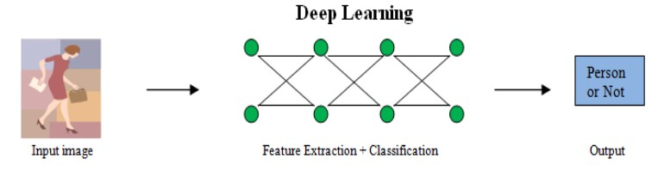
Figure 2-1 Deep Learning Model [11]
Deep Learning techniques solve the problem end to end where it extracts the features from the data and undergoes classification basing on that it provides the results. It teaches the machines to imitate humans intelligence and let the network learn features by itself. Deep learning architectures can be constructed using multi layered structure method.
2.2.2 Deep Learning
Deep Learning also known as deep neural learning or deep neural network. It belongs to the family of machine learning based ona artificial neural networks with future learning. This Learning can be supervised or unsupervised.
Deep neural networks, deep stacking networks, recurrentneural networks, convolutional neural networks are some of the Deep learning architectures. They have been applied to fields like customer experience, computer vision, medical research, speech recognition, natural language processing, social network filtering, Industrial automation, machine translation, text generation , bioinformatics, drug design, medical diagnosis where they have produced approximate results and in some cases striking the human expert performance. In deep learning each level learns to alter its input data into representation which is abstract and composite.
Deep learning algorithms can also be applied to unsupervised learning tasks. Because unlabelled data are more copious than the labelled data. These techniques are effective where lots of unlabelled unstructured data is present.
2.3 Convolutional Neural Networks
Convolution Neural Network is neural network where in short it is called CNN, which is mostly used in Natural language processing.
The convolutional layer consists of a set of filters and kernels for better semantic representations of words having a different length. The significant actions performed are matrix multiplications (non-linear operation) passes through an activation function to produce the final output. In our proposed model, we have used three parallel blocks of 2D-CNN having one layer in each block and two straight forward layers after the concatenation process with different kernel sizes and filters.
The best thing about a CNN is, it automatically designs the kernel during the training phase. This process uses the input data to determine what the kernels for each layer should look like to detect specific image characteristics (e.g. shapes, intensity, textures, contrast, etc.).

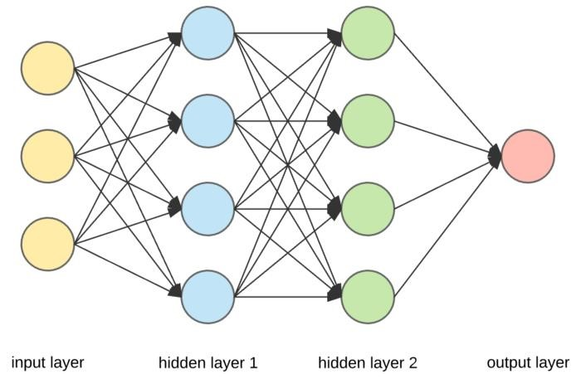
Figure 2-2 Convolutional Neural Networks [17]
In case of one-dimensional CNN (Conv1D) is used generally. Conv-1D deals with one dimensional arrays representing word vectors. The sentences are first tokenized into words to perform sentence modeling and classification with a basic CNN. Words are converted into a word embedding matrix.
2.4 AlexNet
AlexNet is a deep convolutional neural network architecture that was developed by Alex Krizhevsky, Ilya Sutskever, and Geoffrey Hinton in 2012. AlexNet was the winner of the ImageNet Large Scale Visual Recognition Challenge (ILSVRC) in 2012, which was the first time a deep learning model had achieved state-of-the-art performance on the task of image classification.
AlexNet consists of eight layers, five convolutional layers and three fully connected layers. The first convolutional layer has 96 kernels of size 11x11, and the subsequent convolutional layers have smaller kernel sizes. The max-pooling layer follows each convolutional layer. The fully connected layers have 4096 neurons each, followed by the output layer with 1000 neurons (corresponding to the 1000 classes in the ImageNet dataset).
AlexNet also introduced several key innovations that made it more effective than previous neural network architectures. These include the use of ReLU activation functions, which sped up training by allowing for faster convergence, and the use of dropout regularization, which prevented overfitting by randomly dropping out neurons during training.
Alexnet Architecture
One thing to note here, since Alexnet is a deep architecture, the authors introduced padding to prevent the size of the feature maps from reducing drastically. The input to this model is the images of size 227X227X3.
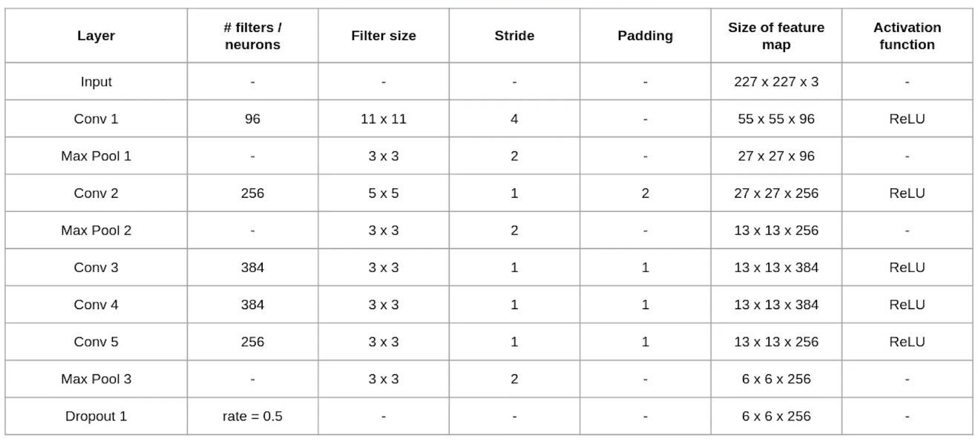
Fully Connected and Dropout Layers
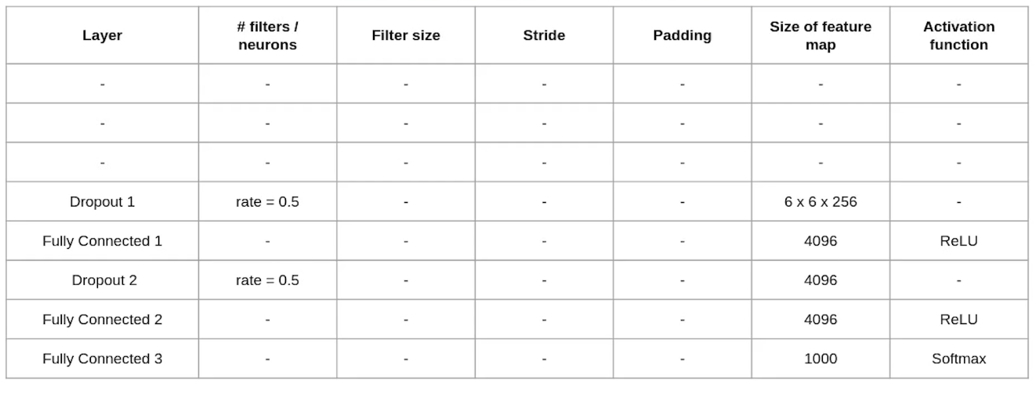
HMM Model
A Hidden Markov Model (HMM) is a statistical model that is used to analyze and predict patterns in sequential data, where the data is assumed to be generated by an underlying probabilistic process that is not directly observable. In an HMM, the state of the system is assumed to be hidden, and only a sequence of observable symbols or events is available.
The model consists of two components: a hidden Markov process that generates the sequence of hidden states, and an observable process that generates the sequence of observed symbols. The hidden Markov process is assumed to be a Markov chain, meaning that the probability of transitioning to a new state depends only on the current state and not on the past history of the system.
The observable process is assumed to be conditionally dependent on the hidden state of the system, meaning that the probability distribution of the observed symbols depends on the current state of the system. The joint probability distribution of the observed symbols and the hidden states can be efficiently computed using the forward-backward algorithm.
HMMs have a wide range of applications, including speech recognition, handwriting recognition, bioinformatics, and finance. They can be trained using the Baum-Welch algorithm, which is a variant of the Expectation-Maximization algorithm, to estimate the model parameters from a set of training data.

2.5 METHODOLOGY
2.5.1 DATA DESCRIPTION
- Our datasets consists of Landslide and Non Landslide images.
- We have total 770 Landslide images and 2003 Non Landslide images
- Further we divided this dataset into train and test datasets with 2000 and 773 images respectively.
- In train dataset we have 500 landslide images and 1500 non landslide images.
- In test dataset we have 270 landslide images and 503 non landslide images.

TESTING

Precision
Precision is used to calculate the ratio between the number of Positive samples correctly classified to the total number of samples classified as Positive, The precision reflects how reliable the model is in classifying samples as Positive.

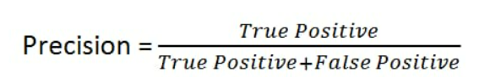
Recall
Recall is used to calculate ratio between the number of Positive samples correctly classified as Positive to the total number of Positive samples. The higher the recall, the more positive samples detected. This is independent of how the negative samples are classified, e.g. for the precision. When the model classifies all the positive samples as Positive, then the recall will be 100% even if all the negative samples were incorrectly classified as Positive.

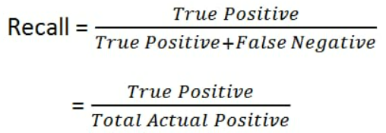

F1_Score
F1 score is a commonly used metric to evaluate the performance of binary classification models. It combines precision and recall to give a single score that represents the harmonic mean of the two.
Precision is the ratio of true positive predictions to the total number of positive predictions, and it measures how many of the positive predictions are actually correct. Recall is the ratio of true positive predictions to the total number of actual positive instances in the data, and it measures how many of the actual positive instances are correctly identified.
The F1 score is defined as 2 times the product of precision and recall divided by their sum:
F1 Score = 2 * (Precision * Recall) / (Precision + Recall)

CONCLUSION

